

# Class : 9 Subject: Mathematics

Chapter 11 - Constructions Excercise Ex. 11.1

Solution 1

Following are the steps of construction:  
  
(i) Take the given ray PQ. Draw an arc of some radius taking point P as its centre, which intersect PQ at R.

(ii) Taking R as centre and with the same radius as before, draw an arc intersecting the previously drawn arc at S.  
  
(iii) Taking S as centre and with the same radius as before, drawn an arc intersecting the arc at T (see figure)  
  
(iv) Taking S and T as centre, draw arc of same radius to intersect each other at U.  
  
(v) Join PU, which is the required ray making 90o with given ray PQ.

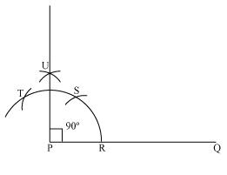

**Justification of Construction:**  
  
We can justify the construction, if we can prove http://images.topperlearning.com/topper/bookquestions/1084_4934c411dbc1a55c0b7875b3e0fc862a.pngUPQ = 90o.  
For this let us join PS and PT

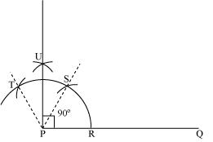

We have http://images.topperlearning.com/topper/bookquestions/1084_4934c411dbc1a55c0b7875b3e0fc862a.pngSPQ = http://images.topperlearning.com/topper/bookquestions/1084_4934c411dbc1a55c0b7875b3e0fc862a.pngTPS = 60o. In (iii) and (iv) steps of this construction, we have drawn PU as the bisector of http://images.topperlearning.com/topper/bookquestions/1084_4934c411dbc1a55c0b7875b3e0fc862a.pngTPS.

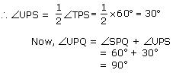

Solution 2

The steps of construction are as follows:  
  
(i)Take the given ray PQ. Draw an arc of some radius taking point P as its centre, which intersect PQ at R.

(ii)Taking R as centre and with the same radius as before, draw an arc intersecting the previously drawn arc  at S.

(iii)Taking S as centre and with the same radius as before, drawn an arc intersecting the arc at T (see figure)  
  
(iv)Taking S and T as centre draw arc of same radius to intersect each other at U.

(v) Join PU. Let it intersect arc at point V.  
  
(vi) Now from R and V draw arcs with other at W with radius more than http://images.topperlearning.com/topper/bookquestions/1085_fcdbbc6bbc2ca084b11561f01b4ff909.png RV to intersect each other. PW is the required ray making 45o with PQ.

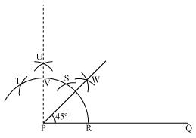

**Justification of Construction:**  
  
To justify the construction, we have to prove http://images.topperlearning.com/topper/bookquestions/1085_4934c411dbc1a55c0b7875b3e0fc862a.pngWPQ = 45o.     Join PS and PT

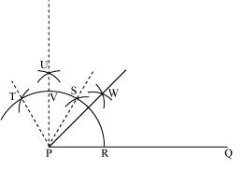

We have http://images.topperlearning.com/topper/bookquestions/1085_4934c411dbc1a55c0b7875b3e0fc862a.pngSPQ = http://images.topperlearning.com/topper/bookquestions/1085_4934c411dbc1a55c0b7875b3e0fc862a.pngTPS = 60o. In (iii) and (iv) steps of this construction, we have drawn PU as the bisector of http://images.topperlearning.com/topper/bookquestions/1085_4934c411dbc1a55c0b7875b3e0fc862a.pngTPS.

http://images.topperlearning.com/topper/bookquestions/1085_im19.JPGhttp://images.topperlearning.com/topper/bookquestions/1085_4934c411dbc1a55c0b7875b3e0fc862a.pngUPS = http://images.topperlearning.com/topper/bookquestions/1085_fcdbbc6bbc2ca084b11561f01b4ff909.png  http://images.topperlearning.com/topper/bookquestions/1085_4934c411dbc1a55c0b7875b3e0fc862a.pngTPS= http://images.topperlearning.com/topper/bookquestions/1085_a85c194caccf87b7c5fe2b1edda04577.png

Now, http://images.topperlearning.com/topper/bookquestions/1085_4934c411dbc1a55c0b7875b3e0fc862a.pngUPQ = http://images.topperlearning.com/topper/bookquestions/1085_4934c411dbc1a55c0b7875b3e0fc862a.pngSPQ + http://images.topperlearning.com/topper/bookquestions/1085_4934c411dbc1a55c0b7875b3e0fc862a.pngUPS  
                  = 60o + 30o  
                  = 90o  
    In step (vi) of this construction, we constructed PW as the bisector of http://images.topperlearning.com/topper/bookquestions/1085_4934c411dbc1a55c0b7875b3e0fc862a.pngUPQ

http://images.topperlearning.com/topper/bookquestions/1085_im19.JPGhttp://images.topperlearning.com/topper/bookquestions/1085_4934c411dbc1a55c0b7875b3e0fc862a.pngWPQ = http://images.topperlearning.com/topper/bookquestions/1085_b37d05ff7c9274cbb87600502ccbfae7.pngUPQ = http://images.topperlearning.com/topper/bookquestions/1085_9130a83f7ac99c8529becc5ad40016da.png  = 45o

Solution 3

(i) 30o

The steps of construction are as follows:  
  
Step I: Draw the given ray PQ. Now taking P as centre and with some radius, draw an arc of a circle which intersects PQ at R.

Step II: Taking R as centre and with the same radius as before, draw an arc intersecting the previously drawn arc at point S.

Step III: Now taking R and S as centre and with radius more than http://images.topperlearning.com/topper/bookquestions/1086_fcdbbc6bbc2ca084b11561f01b4ff909.png RS draw arcs to intersect each other at T. Join PT which is the required ray making 30o with the given ray PQ.

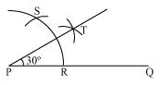

(ii) 22http://images.topperlearning.com/topper/bookquestions/1086_23af013e9aa403d88abd5021a5d81c96.png

          The steps of construction are as follows:  
      
(i) Take the given ray PQ. Draw an arc of some radius, taking point P as its centre, which intersect PQ at R.  
  
(ii) Taking R as centre and with the same radius as before, draw an arc intersecting the previously drawn arc at S.

(iii) Taking S as centre and with the same radius as before, drawn an arc intersecting the arc at T (see figure)

(iv) Taking S and T as centre draw arc of same radius to intersect each other at U.  
  
(v) Join PU. Let it intersect arc at point V.

(vi) Now from R and V draw arcs with radius more than  RV to intersect each http://images.topperlearning.com/topper/bookquestions/1086_fcdbbc6bbc2ca084b11561f01b4ff909.png other at W. Join PW.  
              
(vii) Let it intersects the arc at X. Taking X and R as centre and radius more than http://images.topperlearning.com/topper/bookquestions/1086_fcdbbc6bbc2ca084b11561f01b4ff909.png RX draw arcs to intersect each other at Y. Joint PY which is the required ray making 22http://images.topperlearning.com/topper/bookquestions/1086_23af013e9aa403d88abd5021a5d81c96.png  with the given ray PQ.

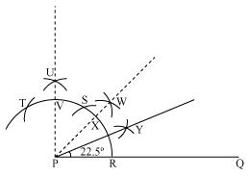

(iii) 150

The steps of construction are as follows:

Step I: Draw the given ray PQ. Now taking P as centre and with some radius, draw an arc of a circle which intersects PQ at R.

Step II: Taking R as centre and with the same radius as before, draw an arc intersecting the previously drawn arc at point S.

Step III: Now taking R and S as centre and with radius more than 1/2 RS draw arcs to intersect each other at T. Join PT

Step IV: Let is intersects the arc at U. Now taking U and R as centre and with 1/2 radius more than RU draw arc to intersect each other at V. Join PV which is the required ray making 15o with given ray PQ.

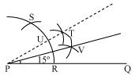

Solution 4

(A) 75o  
The steps of construction are as follows:  
  
(i)  Take the given ray PQ. Draw an arc of some radius taking point P as its centre, which intersect PQ at R.  
  
(ii) Taking R as centre and with the same radius as before, draw an arc intersecting the previously drawn arc at  S.

(iii) Taking S as centre and with the same radius as before, drawn an arc intersecting the arc at T (see figure)  
  
(iv) Taking S and T as centre draw arc of same radius to intersect each other at U.

(v)  Join PU. Let it intersects the arc at V. Now taking S and V as centre draw arcs with radius more than1/2   SV. Let those intersect each other at W. Join PW, which is the required ray making 75o with the given  ray PQ.

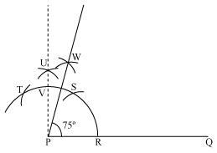

Now, we can measure the angle so formed with the help of a protractor. It comes to be 75o.  
  
(B) 105o

The steps of construction are as follows:

(i) Take the given ray PQ. Draw an arc of some radius taking point P as its centre, which intersect PQ at R.

(ii) Taking R as centre and with the same radius as before, draw an arc intersecting the previously drawn arc at S.

(iii) Taking S as centre and with the same radius as before, drawn an arc intersecting the arc at T (see figure)

(iv) Taking S and T as centre draw arc of same radius to intersect each other at U.

(v) Join PU. Let it intersects the arc at V. Now taking T and V as centre draw arcs with radius more than 1/2 TV. Let these arcs intersect each other at W. Join PW, which is the required ray making 105o with the given ray PQ.

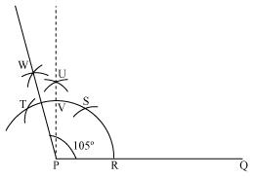

Now, we can measure the angle so formed with the help of a protractor. It comes to be 105o.  
                                                                                         
(C) 135o  
The steps of construction are as follows:

(i) Take the given ray PQ. Extend PQ on opposite side of Q. Draw a semicircle of some radius taking point P as its centre, which intersect PQ at R and W.

(ii) Taking R as centre and with the same radius as before, draw an arc intersecting the previously drawn arc at S.

(iii)Taking S as centre and with the same radius as before, drawn an arc intersecting the arc at T (see figure)  
  
(iv) Taking S and T as centre, draw arc of same radius to intersect each other at U.  
  
(v) Join PU. Let it intersect the arc at V. Now taking V and W as centre and with radius more than 1/2  VW draw arcs to intersect each other at X. Join PX which is the required ray making 135owith the given line PQ.

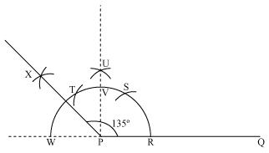

Now, we can measure the angle so formed with the help of a protractor. It comes to be 135o.

Solution 5

We know that all sides of an equilateral triangle are equal. So, all sides of this equilateral triangle will be 5 cm.  
Also, each angle of an equilateral triangle is 60.  
      
The steps of construction are as follows:

**Step I:** Draw a line segment AB of 5 cm length. Draw an arc of some radius, while taking A as its centre. Let it intersect AB at P.

**Step II:** Now taking P as centre draw an arc to intersect the previous arc at E. Join AE.

**Step III:**Taking A as centre draw an arc of 5 cm radius, which intersects extended line segment AE at C. Join AC and BC.  Triangle ABC is the required equilateral triangle of side 5 cm.

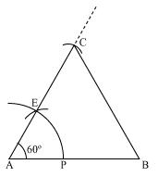

Justification of Construction:  
To justify the construction, we have to prove that ABC is an equilateral triangle i.e.AB = BC = AC = 5 cm and ∆A =  ∆B =  ∆C = 60o.  
   
Now, in  ∆ABC, we have AC = AB = 5 cm and https://images.topperlearning.com/topper/bookquestions/1088_4934c411dbc1a55c0b7875b3e0fc862a.pngA = 60o  
Since, AC = AB, we have  
https://images.topperlearning.com/topper/bookquestions/1088_4934c411dbc1a55c0b7875b3e0fc862a.pngB = https://images.topperlearning.com/topper/bookquestions/1088_4934c411dbc1a55c0b7875b3e0fc862a.pngC                         (angles opposite to equal sides of a triangle)  
Now, in https://images.topperlearning.com/topper/bookquestions/1088_ec7fd5b2b4109644a398eba4d25ebf00.pngABC  
https://images.topperlearning.com/topper/bookquestions/1088_13fb2c7abb7fb90f3d38dc838d646ea3.pnghttps://images.topperlearning.com/topper/bookquestions/1088_4934c411dbc1a55c0b7875b3e0fc862a.pngA + https://images.topperlearning.com/topper/bookquestions/1088_4934c411dbc1a55c0b7875b3e0fc862a.pngB + https://images.topperlearning.com/topper/bookquestions/1088_4934c411dbc1a55c0b7875b3e0fc862a.pngC = 180o    (angle sum property of a triangle)  
 https://images.topperlearning.com/topper/bookquestions/1088_13fb2c7abb7fb90f3d38dc838d646ea3.png60o + https://images.topperlearning.com/topper/bookquestions/1088_4934c411dbc1a55c0b7875b3e0fc862a.pngC + https://images.topperlearning.com/topper/bookquestions/1088_4934c411dbc1a55c0b7875b3e0fc862a.pngC = 180o  
 https://images.topperlearning.com/topper/bookquestions/1088_13fb2c7abb7fb90f3d38dc838d646ea3.png60o + 2 https://images.topperlearning.com/topper/bookquestions/1088_4934c411dbc1a55c0b7875b3e0fc862a.pngC = 180o  
https://images.topperlearning.com/topper/bookquestions/1088_13fb2c7abb7fb90f3d38dc838d646ea3.png 2 https://images.topperlearning.com/topper/bookquestions/1088_4934c411dbc1a55c0b7875b3e0fc862a.pngC = 180o - 60o = 120ohttps://images.topperlearning.com/topper/bookquestions/1088_13fb2c7abb7fb90f3d38dc838d646ea3.png https://images.topperlearning.com/topper/bookquestions/1088_4934c411dbc1a55c0b7875b3e0fc862a.pngC = 60o

https://images.topperlearning.com/topper/bookquestions/1088_ma215.JPG

Now, we have https://images.topperlearning.com/topper/bookquestions/1088_4934c411dbc1a55c0b7875b3e0fc862a.pngA = https://images.topperlearning.com/topper/bookquestions/1088_4934c411dbc1a55c0b7875b3e0fc862a.pngB = https://images.topperlearning.com/topper/bookquestions/1088_4934c411dbc1a55c0b7875b3e0fc862a.pngC = 60o              ... (1)

https://images.topperlearning.com/topper/bookquestions/1088_13fb2c7abb7fb90f3d38dc838d646ea3.pnghttps://images.topperlearning.com/topper/bookquestions/1088_4934c411dbc1a55c0b7875b3e0fc862a.pngA = https://images.topperlearning.com/topper/bookquestions/1088_4934c411dbc1a55c0b7875b3e0fc862a.pngB and https://images.topperlearning.com/topper/bookquestions/1088_4934c411dbc1a55c0b7875b3e0fc862a.pngA = https://images.topperlearning.com/topper/bookquestions/1088_4934c411dbc1a55c0b7875b3e0fc862a.pngC

https://images.topperlearning.com/topper/bookquestions/1088_13fb2c7abb7fb90f3d38dc838d646ea3.pngBC = AC and BC = AB          (sides opposite to equal angles of a triangle)

https://images.topperlearning.com/topper/bookquestions/1088_13fb2c7abb7fb90f3d38dc838d646ea3.pngAB = BC = AC = 5 cm                                  ... (2)

Equations (1) and (2) show that the https://images.topperlearning.com/topper/bookquestions/1088_ec7fd5b2b4109644a398eba4d25ebf00.pngABC is an equilateral triangle.